What is Forest School?
Forest school is an inspirational process that has been evolving in the UK since the early
1990’s.
It fits in to the realm of outdoor education, but differs by being child led.
Children are allowed to direct their own learning, following their interests. Forest school staff are there to provide inspiration, stimulate and scaffold, but mainly just to observe learning. Through exciting and stimulating play, children learn about themselves, others and the world around them.
Play at Forest school allows children to encounter and experience risk in a safe and supported environment. This may be through climbing a tree, using unfamiliar tools, making fires or just working with someone that they do not know.
Children will always be encouraged to identify and access their own risks. Eventually this will become autonomous.
Children engage in achievable tasks and activities throughout the year and in all weathers. This allows children to observe the changes to seasons, experience weather and develop a relationship with nature that they will take through their adult lives.
What are the benefits of forest school for my child?
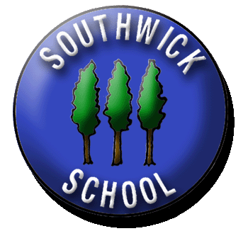

Forest school supports the holistic development of children. It will benefit them by:
• Increasing social skills; Children share, negotiate, lead and problem solve with their peers.
• Increasing confidence through small, manageable tasks.
• Gaining knowledge and understanding of their natural environment, the plants and animals that live there and the change in seasons.
• Understanding their own strengths, weaknesses and learning styles.
• Increasing emotional wellbeing. Being in nature has been shown to have a real and positive effect to children’s mental wellbeing.
• Developing new skills using tools and traditional crafts.
• Having an opportunity to play and follow their own agenda.
• For some children, it can form a new relationship with learning that they can take back in to the classroom.

Forest School
Information
for Parents

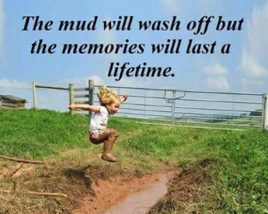
What does my child need to bring?
What activities happen at a forest school session?

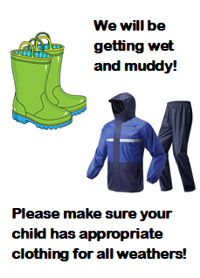
Children are best wearing several thin layers that can be added or removed as needed. Children will need the following items of clothing:
• Waterproof trousers and jacket
• Wellingtons, walking boots or old trainers
• Long sleeve tops and full length trousers in all weathers (to prevent scratches, bites and provide sun protection)
• A sun hat and sun cream for warm days and a woolly hat for colder weather.
We will be digging, climbing and playing on the ground.
Please bring old clothes that can get dirty.
How Can I help?
Firstly, talk to your children and let them share their exciting adventures with you. Please make sure that your children have appropriate clothing and, if it is warm, are wearing sun cream. If you feel that you have anything else that you can contribute to our woodland environment, such as wood to use for crafts, firewood, large tarps or other resources please let us know.
Sessions will have a focus on building resilience and social skills.
A lot of the session time will consist of child initiated activities. Each week there will be a planned activity that the children can choose to do.
This may include
• Fire making
• Cooking
• Supervised use of tools (Bow saw,
Potato peelers, palm drills)
• Woodland craft
• Nature studies
• Den building

All activities are risk assessed and under supervision from the forest school leader with appropriate
adult: child ratios.

